Introduction & Data Modelling Overview
This report outlines the comprehensive performance analysis of the ShopNest Store platform using structured visualizations. To enable cross-functional evaluation, a multi-table star schema data model was implemented. Crucially, the cross-filter directions between the central Nexusgoods_products_dataset and transactions were configured to Both to guarantee that category classifications correctly trickle down to order and fulfilment metrics without distorting aggregate evaluations.

1. Top Categories by Total Price:
Question Statement
Identify and visually represent the top 10 product categories by total sales.
Visualization
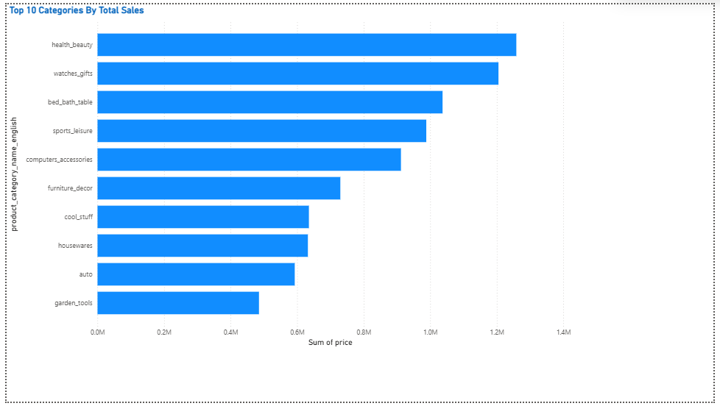
Explanation
These visual highlights the most lucrative sectors of the store's inventory by calculating the descending sum of item prices across categories. Limiting the view to the top 10 categories allows leadership to instantly isolate the highest-grossing products from low-volume niches. This baseline data helps allocate marketing budgets toward dominant categories while signalling opportunities to scale inventory for maximum gross-merchandise value.

2. Delayed Orders Analysis:
Question Statement
Determine the number of delayed orders in each category. An order is considered delayed if the actual delivery date is later than the estimated delivery date.
Visualization
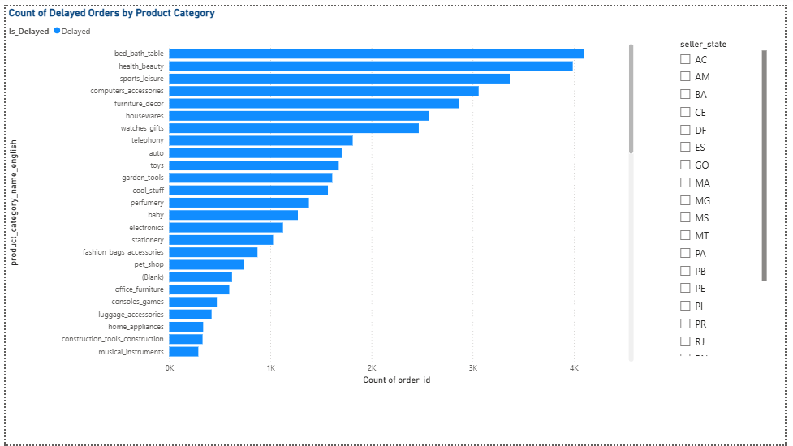
Explanation
This visual calculates order fulfilment efficiency by isolating orders where the actual delivery date exceeded the promised estimated arrival timeline. To deepen the analysis, an integrated Seller_State slicer allows the user to filter the data interactively. The insights show whether certain product types are inherently prone to fulfilment friction, or if operational delays are structurally tied to specific geographic shipping hubs and regional seller centres.

3. Monthly Comparison of Delayed and On-Time Orders:
Question Statement
Create a dynamic visual that compares the number of delayed orders to the number of orders received earlier for each month. Utilize the drillthrough cross-report feature to provide a detailed analysis of late and on-time deliveries.
Visualization
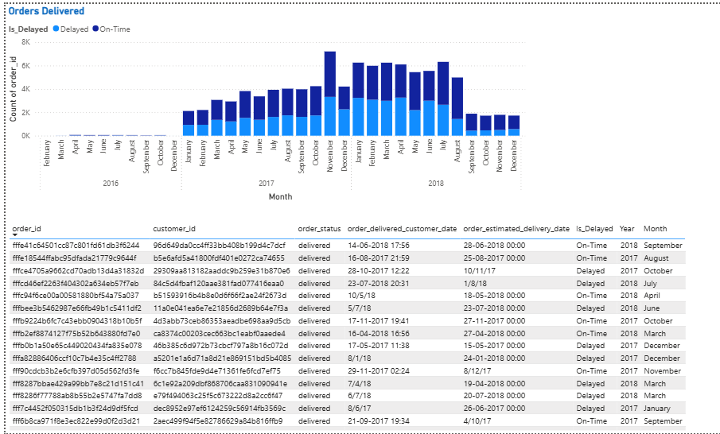
Explanation
Using a categorical chronological axis, this chart visualizes the ratio of successful on-time deliveries against delayed fulfilments month-over-month. The chart highlights critical patterns, such as delivery performance drops during high-volume holiday sales windows (e.g., Q4 rush). By implementing a right-click drillthrough filter path to a granular detail table, analysts can instantly investigate the exact order profiles driving historical operational delays.

4. Payment Method Analysis:
Question Statement
Analyze the most frequently used payment methods by customers using a visually appealing representation, such as a pie chart or other suitable visuals.
Visualization
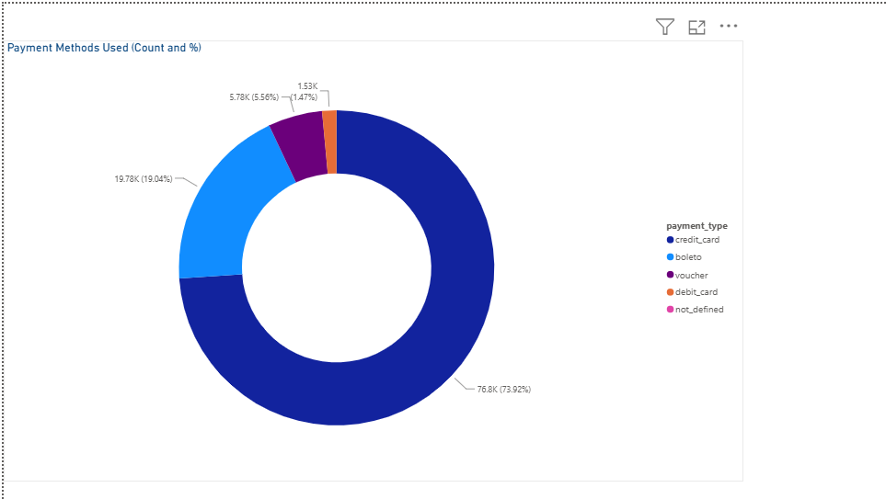
Explanation
This donut chart visually presents customer checkout behaviour by computing the proportional breakdown of total transaction IDs across payment mediums. It isolates which financial gateways handle the bulk of ShopNest's volume. These breakdown metrics allow fintech teams to negotiate favourable vendor transaction rates for dominant payment methods and streamline payment interface design to reduce cart abandonment.

5. Product Rating Analysis:
Question Statement
Determine the top 10 highest-rated products and the bottom 10 lowest-rated products using a bar or column chart.
Visualization
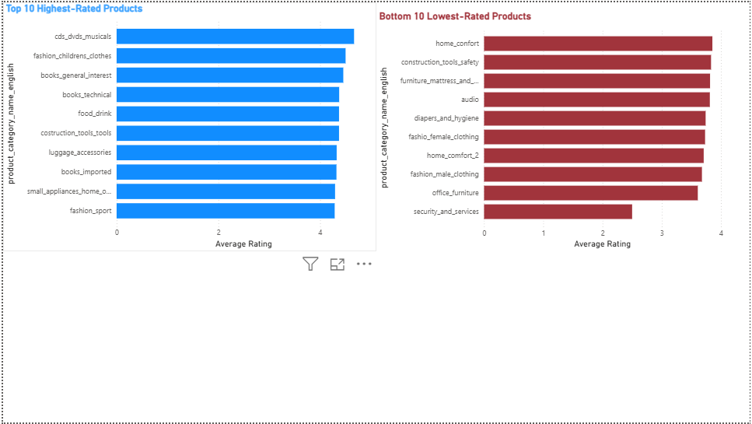
Explanation
Using a customized DAX average measure, these dual charts separate exemplary items from problematic inventory pieces. Grouping the top 10 and bottom 10 products gives quality assurance teams a clear plan of action. Excellent items can be heavily promoted or bundled, while low-performing products with poor average review scores can be flagged for vendor replacement or immediate inventory liquidation.

6. State-wise Sales Analysis:
Question Statement
Identify and visually represent states with high and low sales, providing a clear understanding of regional sales performance.
Visualization
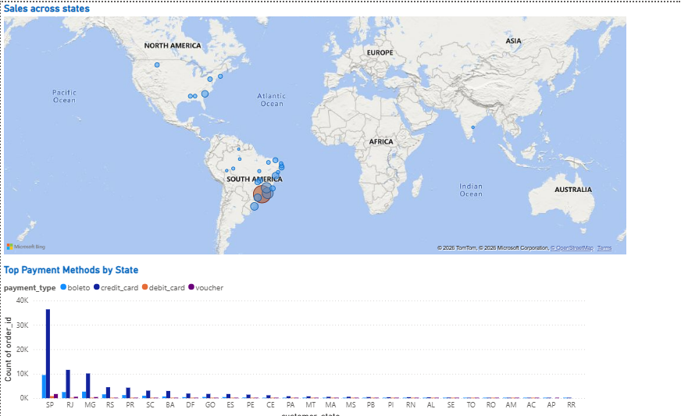
Explanation
These geographic visual maps total sales values across different states to reveal regional consumer distribution. To enhance localized targeting, a supporting column chart breaks down payment choices by state. This combination uncovers unique regional patterns—showing if certain states heavily favour alternative payment methods over standard credit lines—enabling highly targeted regional marketing and tailored logistics placement.

7. Seasonal Sales Patterns:
Question Statement
Investigate and visualize any seasonal patterns (Quarterly) or trends in sales data over the course of the year.
Visualization
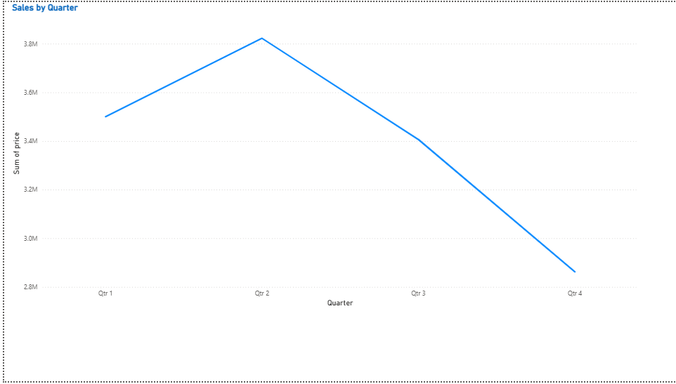
Explanation
This visualization traces total gross performance across standard annual quarters (Q1 through Q4) to capture cyclical purchasing shifts. By clearing short-term daily volatility, the continuous line visual highlights recurring corporate seasonal trends. These regular patterns give operational management the historical baseline needed to optimize warehouse stocking levels and plan seasonal workforce adjustments ahead of predictable demand spikes.

8. Revenue Analysis:
Question Statement
Determine the total revenue generated by ShopNest Store and analyse how it changes over time (Yearly). Represent this information through suitable visuals to highlight trends and patterns.
Visualization
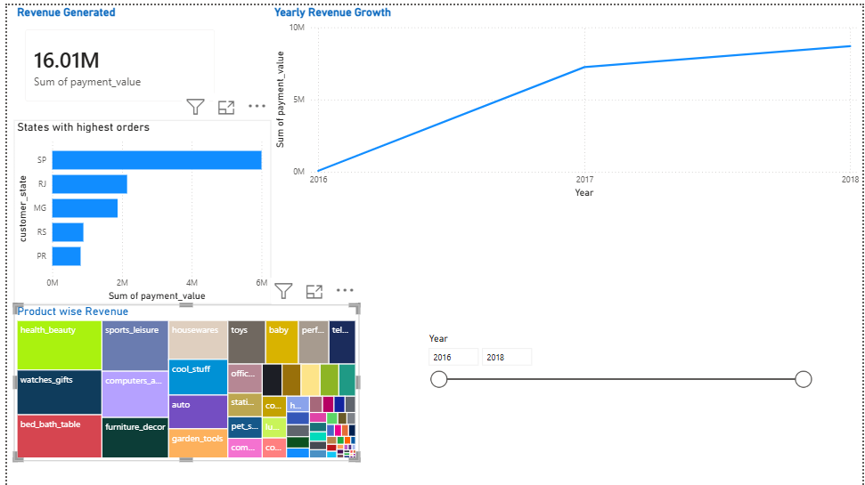
Explanation
This section displays high-level financial health metrics for executive stakeholders, pairing a large lifetime revenue KPI card with a yearly growth line graph. The chart demonstrates ShopNest's long-term market traction. It shows macro growth trends, proving fiscal stability and validating the company's long-term business strategy over time.

